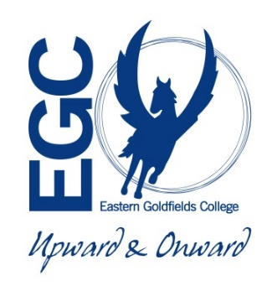**GENERAL INTEGRATED SCIENCE– UNIT 4**

**TASK 8 – Fermentation Reactions in Food**

**NAME: _____________________________________ WEIGHTING: 7.5 %**

**DATE: _______________________________________ MARK: ______ % =**

Fermentation is a metabolic process in which an organism [converts a carbohydrate](https://www.thoughtco.com/chemistry-of-carbohydrates-603878), such as starch or a [sugar](https://www.thoughtco.com/chemical-formula-of-sugar-604003), into an [alcohol](https://www.thoughtco.com/alcohol-versus-ethanol-3976082) or an acid. For example, yeast performs fermentation to obtain energy by converting sugar into alcohol. Bacteria perform fermentation, converting carbohydrates into lactic acid.

**Examples of Products Formed by Fermentation**

Most people are aware of food and beverages that are fermentation products:

* Beer
* Wine
* Yogurt
* Cheese
* Certain sour foods containing lactic acid, including sauerkraut, kimchi, and pepperoni
* Bread leavening by yeast

**Task 1 – documentary answers (10%)**

Answer the questions while watching the documentary

**Task 2 – research notes (50%) (27 marks)**

Choose one of the products from the list above or another product of your choice (check with your teacher before starting research).

You are to research and create a set of notes on how this food product is formed using the process of fermentation. You can choose any product that is of interest and some examples are given above.

**Task 3 – presentation (40%) (11 marks)**

Make a presentation that will inform young people on how your chosen product is made using the fermentation process. The presentation can be any form you choose from Pod cast, slide show, video, poster etc.

The following questions will guide what you need to research about your product. The same information will then be incorporated in your presentation and you will be marked on how well you communicate the information – you need to imagine you’re explaining your product to year ten students. There will be marks allocated to:

* Use of images and/or sound – are there any? Do they help the audience understand your topic? (2 marks)
* Writing skills – is it easy for the reader to understand? (2 marks)
* Organisation – is the information in a logical order? (1 mark)
* Content – is the information correct? Is all the required information there? (4 marks)
* Visual appeal – is your presentation pleasant to look at? Is it neat and tidy? (2 marks)

**Research questions (27 marks)**

1. What is fermentation? (2 marks)
2. Research the three types of fermentation and explain which one of the three main types does your food product use. (4 marks)
3. What are the three main stages of general food fermentation, discuss the reactants and the formation of the products. (6 marks)
4. Describe the food product you have chosen to research using chemical terminology. (3 marks)
5. Explain how your food product is made, outlining how fermentation is brought about, used and controlled during the process. (6 marks)
6. Explain how the fermentation process is halted. (3 marks)
7. Explain how the food product is stored so that it is kept in the best condition for consumption. (3 marks)